NAME: EKENG, AKANINYENE IME
COURSE: SECURITY OPERATIONS CENTER (SOC) ROLE IN BLUE TEAM
COHORT: NOVARA 28 NOVERMBER 2025
DATE:18/02/2026

TITLE: To study SOC Roles and Responsibilities within the Blue Team
AIM: To understand the role of the Security Operations Center (SOC) within the Blue Team, explore the security hierarchy, and learn the responsibilities and career progression of SOC analysts.

INTRODUCTION
In cybersecurity, the “Blue Team” is responsible for defending an organization’s systems, networks, and data from cyber threats. Unlike the Red Team (attackers), the Blue Team focuses on detection, prevention, monitoring, and incident response.
The SOC operates as a core part of the Blue Team and works continuously to detect and respond to threats in real time.

MATERIALS
- TryHackMe platform access
- SOC Role in Blue Team lab access
- Web browser
- Basic knowledge of cybersecurity

PROCEDURES

Step 1: Introduction
- I accessed the SOC Role in Blue Team lab.
- I studied the overview of Blue Team operations.
Step 2: Security Hierarchy
- I clicked on security hierarchy to learn about the structured SOC tiers.
- I understood escalation and reporting flow.
Step 3: Meet the Blue Team
- I clicked on Blue Team to explore different Blue Team roles.
- I identified responsibilities of each role.
Step 4: Advancing SOC Career
- I studied required skills for progression.
- I learned importance of certifications and hands-on practice.
Step 5: Final Challenge
- I completed the practical assessment.
- I answered scenario-based questions.

OBSERVATION
- I observed that, SOC operations rely on teamwork and structured escalation.
- I observed that, L1 analysts play a critical role in filtering alerts.
- I observed that, proper communication between tiers improves response efficiency.
- I observed that, continuous learning is essential in SOC careers.
- I observed that, team operations focus on proactive and reactive defense.

PRECAUTIONS
- Carefully verify alerts before escalation.
- Avoid misclassifying true incidents as false positives.
- Maintain proper documentation during investigations.
- Follow standard operating procedures (SOPs).
- Maintain confidentiality of sensitive data.
- Ensure secure access to monitoring systems.

CONCLUSION
This practical study of the SOC Role in Blue Team provided comprehensive knowledge of defensive cybersecurity operations. It highlighted the importance of structured hierarchy, defined responsibilities, and continuous monitoring.
This exercise enhanced my understanding on; SOC tier roles, Incident handling workflow, Career progression in cybersecurity, Importance of teamwork in Blue Team operations
Overall, the SOC plays a vital role within the Blue Team by ensuring effective detection, investigation, and response to cyber threats, thereby strengthening organizational security.

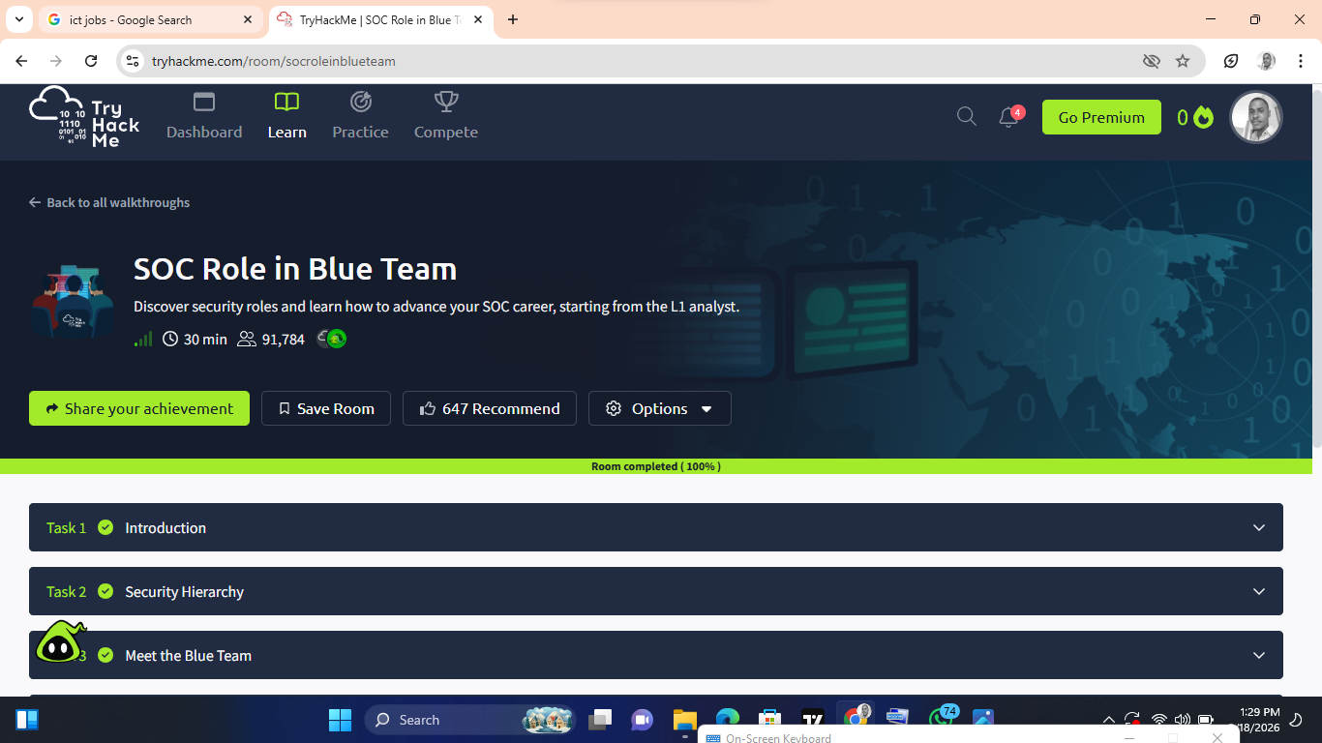
SCREENSHOT OF MY SUCCESSFUL COMPLETION.

